One of the benefits from typhoons is a huge volume of rainfall, which can improve drought conditions all at once. (2015.06.11)

A typical example is what happened to Sameura Dam, located in the upper reach of the Yoshino River in Kochi Prefecture, when Typhoon No.14 hit the Shikoku Region in 2005. In that year, the area upstream of the dam had merely 783 mm of rainfall, 47% of its mean annual rainfall, during the four months from May through August. Because of that, the water use capacity of the dam recorded zero percent of storage twice at 20:00, August 19, and at 8:00, September 1. The Liaison Council for Water Use in the Yoshino River System responded to this crisis by making arrangements to use the remaining volume of the water use capacity as long and as effectively as possible, including water intake restriction. Once the water use capacity had run out, it decided on emergency discharge of the power generation capacity to supply water needed for people’s livelihoods. However, Typhoon No.14 brought heavy rainfall over the area on September 6, filling the dam with approximately 250 million m3 of water in a single day and dramatically improving its percentage of storage to 100% by the midnight of September 7. This finally ended the water intake restriction for water use in Tokushima and Kagawa at 18:00, September 6, after it lasted nearly three months from June 15. The restriction on water intake in the Dozan River was also lifted at 20:00, September 6. As a result, the drought during the summer of 2005 came to an end at last.

The Sameura Dam is built on the Yoshino River, about 140 km upstream from its river mouth. Rising from Mt. Kamegamori in the Shikoku Mountains, the river roughly crosses the center of the Shikoku Island east to west, pouring into the Kii Channel. It is one of the largest rivers in Japan with a total length of 194 km and a basin area of 3,750 km2, which spreads over the four prefectures of the island and accounts for about 20% of its total area. The Setouchi side of the island generally has less rainfall, about 1,250 mm per year, resulting in chronic water shortages. On the other hand, its Pacific side suffers from too much rainfall, over 3,000 mm per year with occasional typhoons, causing flood disasters. To solve this imbalanced water availability, a water management plan was made to lessen flood disaster risk along the Yoshino River by building dams in areas abundant in rainfall to block floodwaters as well as to reduce water shortages in areas with less rainfall by sending stored water for domestic, industrial and agricultural purposes. The Sameura Dam was constructed as a part of this plan.

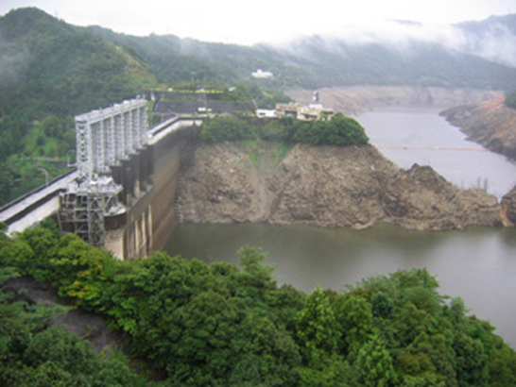

The reservoir level of the Sameura Dam was 280.28 m at around 9:00 on September 5.

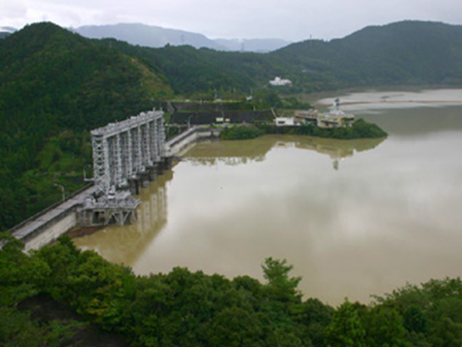

The reservoir level of the Sameura Dam was 338.68 m at around 9:00 on September 7.

Outline of Sameura Dam

|  |  |
| --- | --- |
| River | Yoshino River |
| Cacthment area | 472 km2 |
| Left bank | Motoyama-cho, Kochi Pref. |
| Right bank | Tosa-cho, Kochi Pref. |
| Location: | North latitude: 33゜45’ 24’’  East longitude: 133゜33’ 02’’ |
| Launch of Operation | Apr. 1975 |
| Objective | 1. Enhance flood management  2. Ensure normal flow for  downstream areas  3. Create a new water resource  4. Provide hydro-power |
| Type | Concrete gravity dam |
| Height | 106 m |
| Crest length | 400 m |
| Concrete volume | 1.187 million m3 |
| Capacity (Gross) | 316 million m3 |
| Capacity (Effective) | 289 million m3 |
| Water use capacity | 173 million m3 |



Figure 1 Comparison of the impounded volumes of Sameura Dam (planned, noraml year, 1994, 1995, 2005).

The horizontal axis shows months from January to December and the vertical axis is the impounded volume in 1000 m3. The black, blue, green and pink circles indicate the issuances of water intake restriction, the red circle the emergency discharge of the power generation capacity, and the orange square the temporary lifting of water intake restriction. The impunded volume in 2005 shows an extremely sharp rise in September, hitting a 98.5% level at 0:00 on the 30th after dropping to zero twice in August 19 and September 1.

Basin average rainfall at Yoshino River Basin

|  |  |  |
| --- | --- | --- |
|  | Yoshino River Basin  (Upstream of Sameura Dam) | Yoshino River Basin  (Downstream of Sameura Dam) |
| Start of Rainfall | 20:00, Sep.4 | 21:00, Sep. 4 |
| Total Rainfall (mm) | 691 | 500 |
| Hourly Maximum Rainfall (mm) | 18:00~19:00, Sep. 6  77 | 22:00~23:00, Sep. 6  63 |

Reference:

* 記者発表資料「台風14号における吉野川上流ダム群の洪水調節効果について」2005.Sep.7

国土交通省吉野川ダム統合管理事務所、独立行政法人水資源機構池田総合管理所

Press Release: Flood Management by Dams upstream Yoshino River at Typhoon 14th, 2005.Sep.7, MLIT Yoshino River Integrated Dam Management office, Japan Water Agency Ikeda Integrated Management Office. (originally in Japanese)

* 早明浦ダムパンフレット、「吉野川の地域と水をつなぎます！－地域とともに水資源機構－」独立行政法人水資源機構池田総合管理所

Sameura Dam Brochure, Japan Water Agency, Ikeda Integrated Management Office. (originally in Japanese)

* 大谷忠夫、平成17年夏渇水について、四国技報第5巻10号、2006.Jan.1

Tadao Ootani, Summer Drought in 2005, Shikoku-Giho, 2006. Jan.1 (originally in Japanese)